BBBBB

Updated and Enabled ‘ufw’ on New Linux

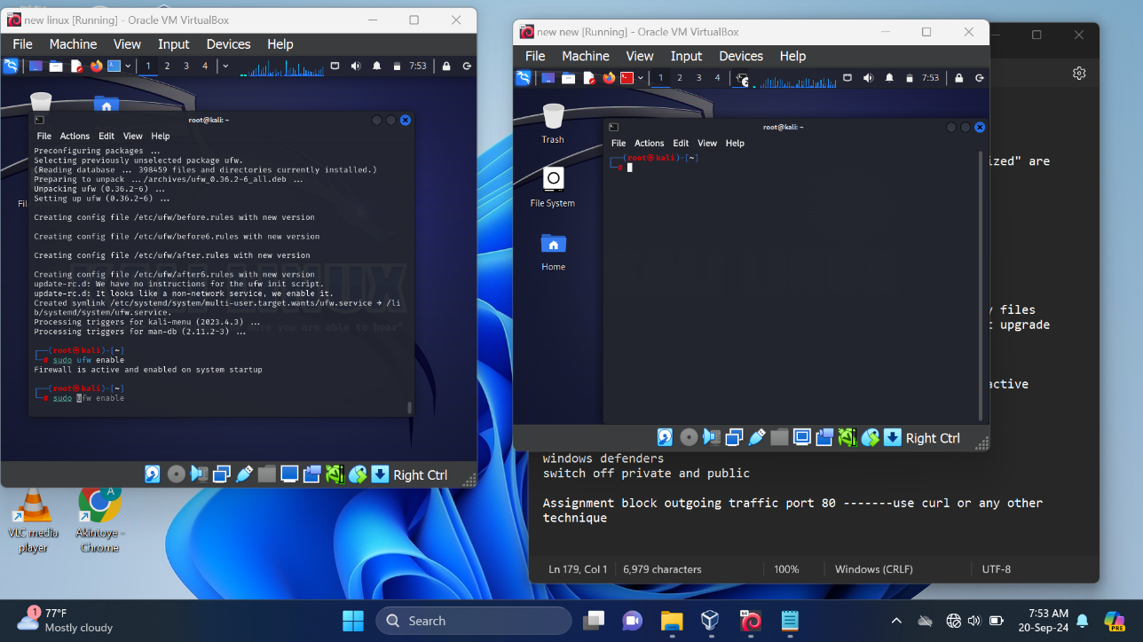

Pinged New New from New Linux and received response and pinged New linux from New New but got no response.

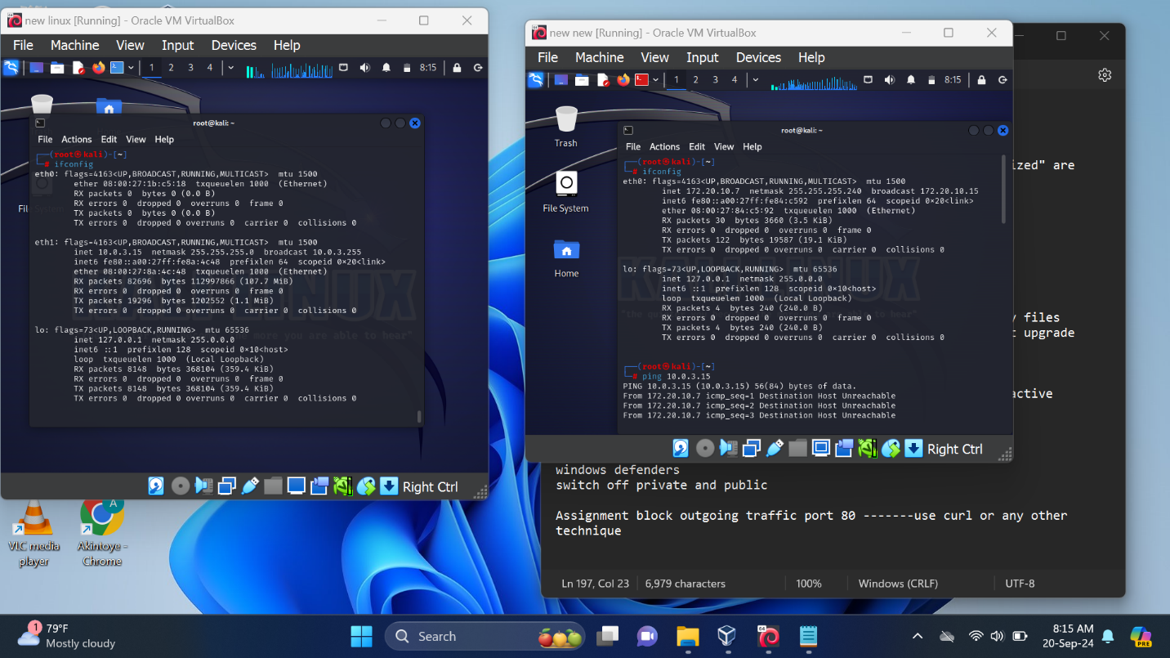

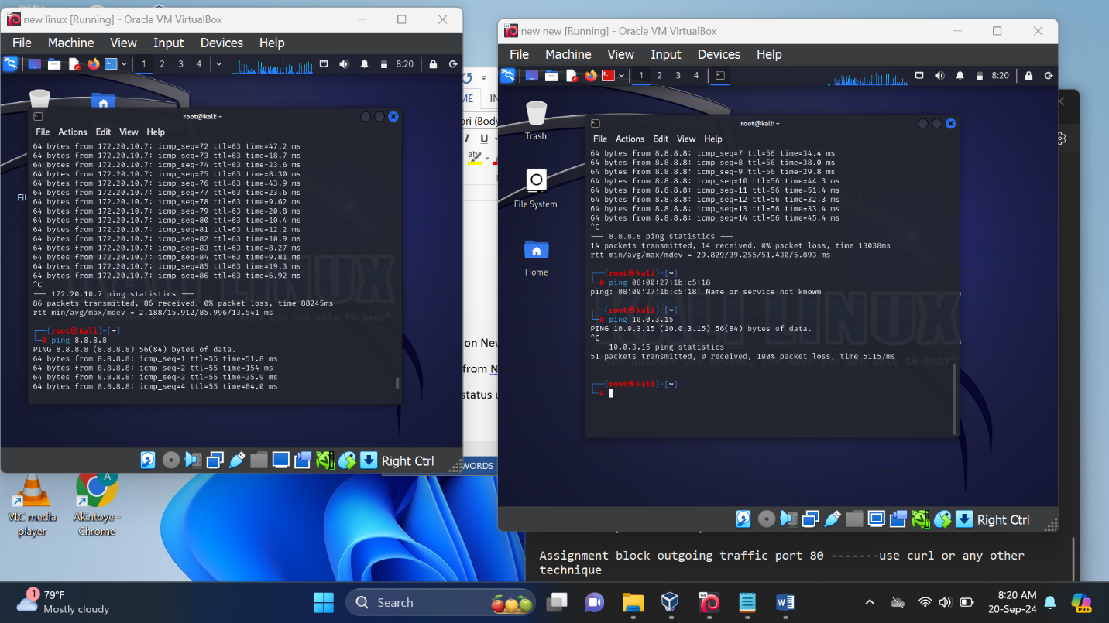

Checked the status using the verbose command and saw that the default denied all incoming but allowed outgoing traffic then allowed all incoming traffic to New Linux

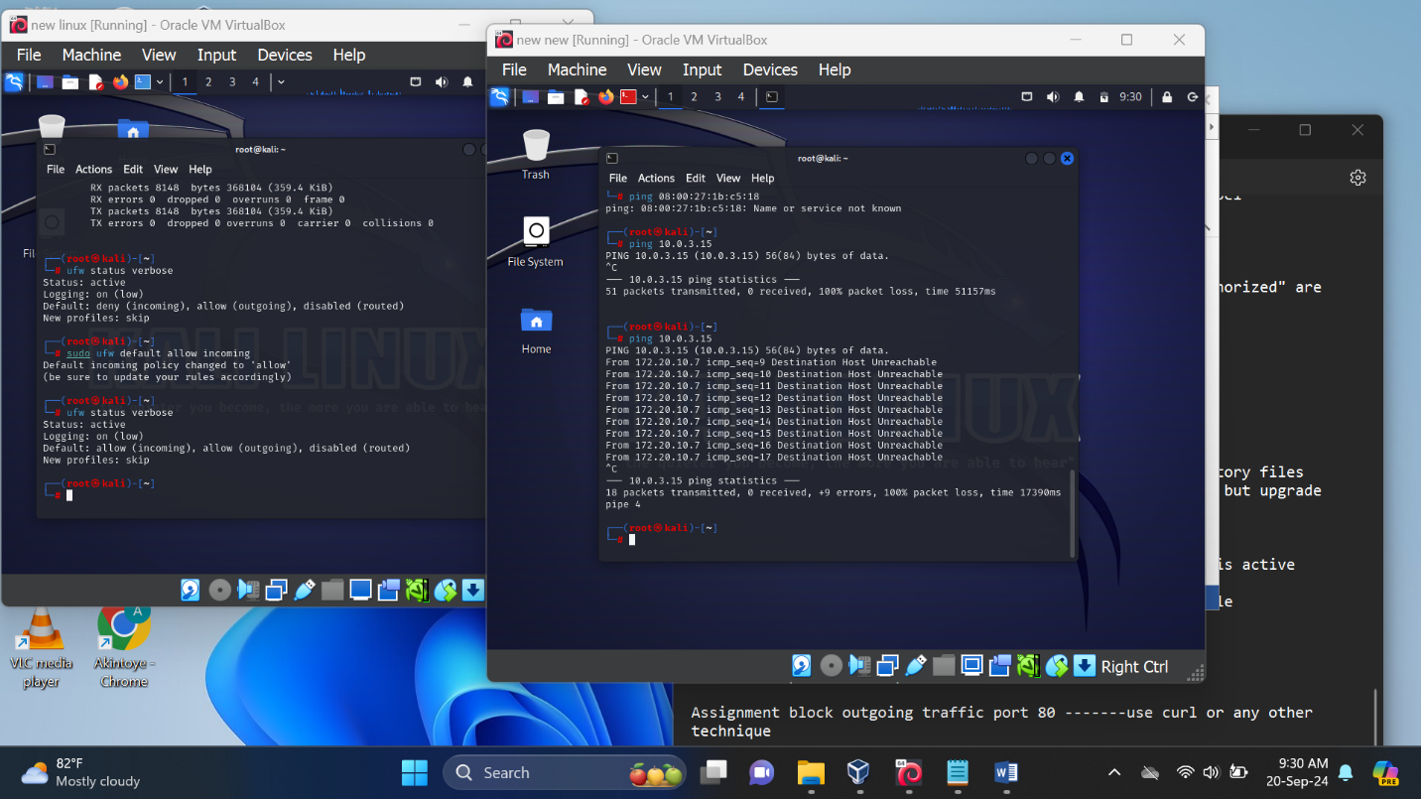

Check for if port 80 is open failed because there is no http protocol setup.

